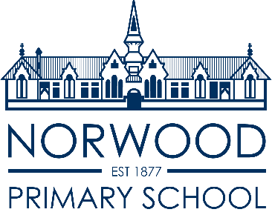

**School Uniform Policy**

At Norwood Primary School we believe that the wearing of school uniform promotes a sense of belonging, pride, safety and unity in our school. Wearing of uniforms enhances our public image, reduces peer pressure and encourages appropriate clothing for school activities. Equality is fostered by a policy common to all students.

Our uniform policy is in accord with the dress code guidelines and policy for public schools under the South Australia Education and Children's Services Regulations 2020 under the Education and Children's Services Act 2019 and is endorsed by the School’s Governing Council, the Principal and the school community. Issues of health, safety, equity and expense have been considered when developing these guidelines.

**It is expected that all students will wear school uniform.**

**The Uniform:**

The uniform is based on the school colours of navy blue and red and consists of:

* Plain navy blue pants or track pants (no denim jeans) or plain navy skorts, skirts or shorts.
* Navy blue or red short sleeved polo shirts (school logo preferred).
* Navy blue windcheaters/polar fleece (school logo preferred).
* Summer dresses of blue/white or red/white check.
* Navy blue legionnaires, broad brimmed hat or navy bucket hat with school logo.
* Winter dress or skirt. (Winter dress to be worn with red, blue or white shirt).
* Navy blue or red school jackets.

**Year 6 Students:**

To encourage a greater sense of identity and responsibility, year 6 students may also wear a navy blue ‘seniors’ windcheater.

**House T-Shirts**

These may be purchased and worn for Sports Day and Swimming Carnival only.

**School Uniform Guidelines:**

The school has an active learning program in most areas of the curriculum and in our grounds there is a range of outdoor play equipment. All children should be suitably attired with comfortable, practical clothing and footwear.

The school uniform is ideal for active participation at school.

Additionally:

* Sandals may be worn in summer (thongs and slip-on shoes are considered dangerous and are not permitted), whilst the wearing of closed in shoes is encouraged at all times.
* Hats are to be worn in terms 1, 3 and 4 (and when UV level reaches 3 or above during term 2)
* Jewellery can frequently be a health and safety risk and is therefore not permitted, other than sleeper or stud earrings, watches, or medically required identification.
* Face makeup and nail polish are not permitted.
* The wearing of brand names on clothing is not permitted (this includes local sports clubs and SAPSASA).

The Principal may exempt students from wearing the school uniform upon written request from a parent or caregiver on cultural, medical or religious grounds.

**The Governing Council will review this policy annually.**

***Policy review date: June 2025***